**Part I**

1. Host a static website on Blob Storage: build and deploy a static Hello

World website to Azure Storage.

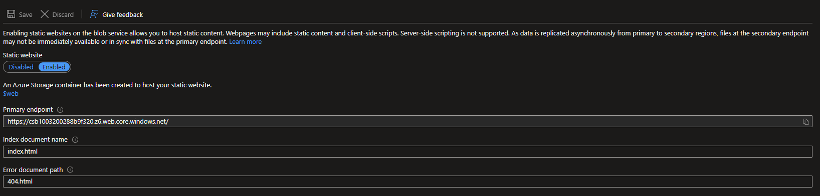

On the Web Container in the storage account we need to upload the HTML file that will output Hello World Content

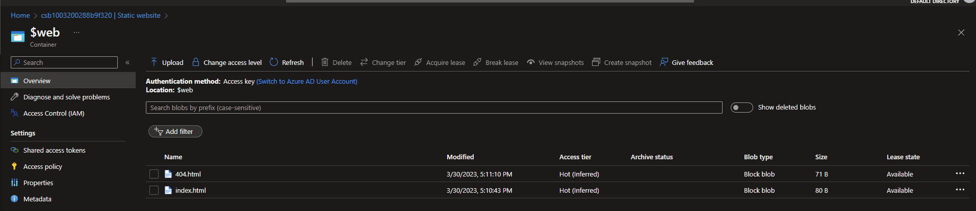

2. Verify that the default web page has the **Hello World!** page.

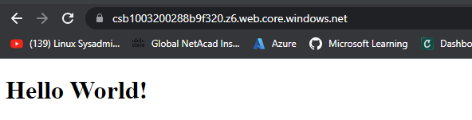

3. Provide the steps and results.

**Part II**

1. Create a Virtual Network where you will deploy your Linux Based

Web Server.

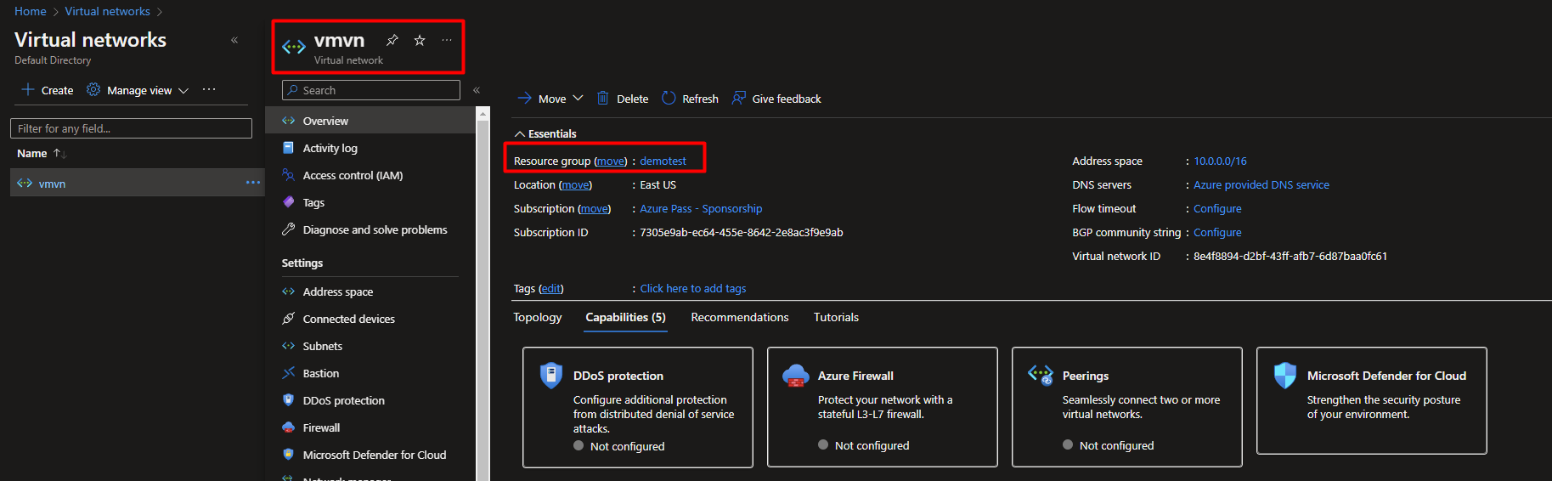

2. Modify the network security group for your virtual machine that will

allow you to remotely manage your machine only from your local

machine and nowhere else.

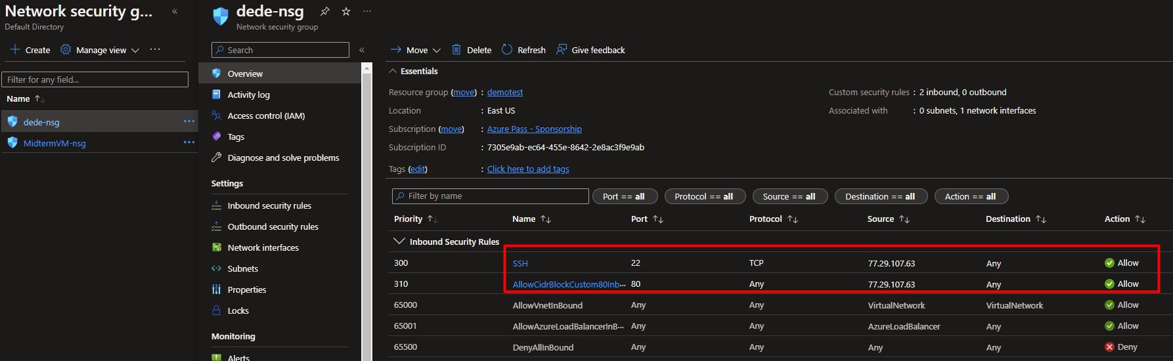

The 77.29.107.63 is the IP of the local computer which will allow remote access only from that IP (local PC).

3. Create a Linux Virtual Machine that will be your Web Server which is

publicly available for web publishing (not SSL) only from your

machine and nowhere else.

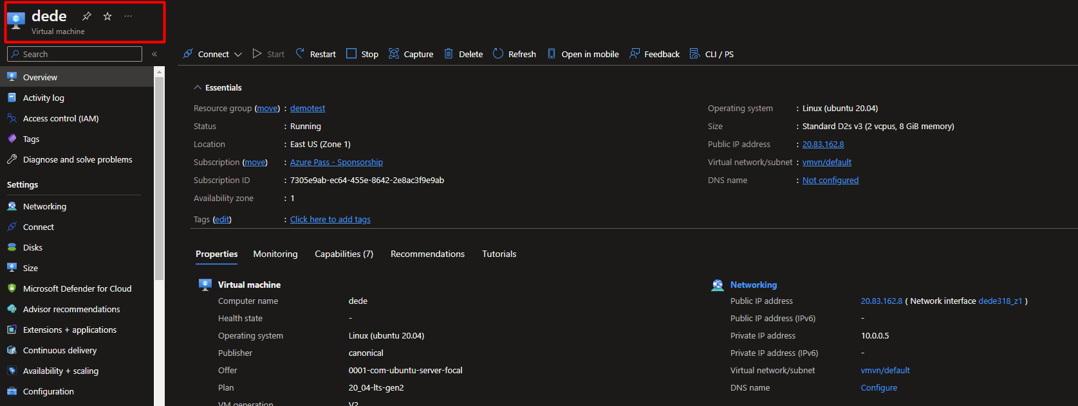

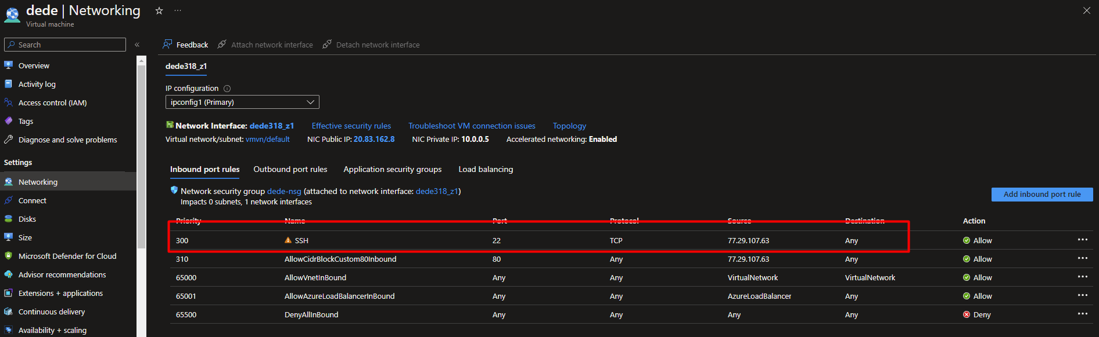

The 77.29.107.63 is the IP of the local computer which will allow publishing only from that IP address.

4. Connect to the VM.

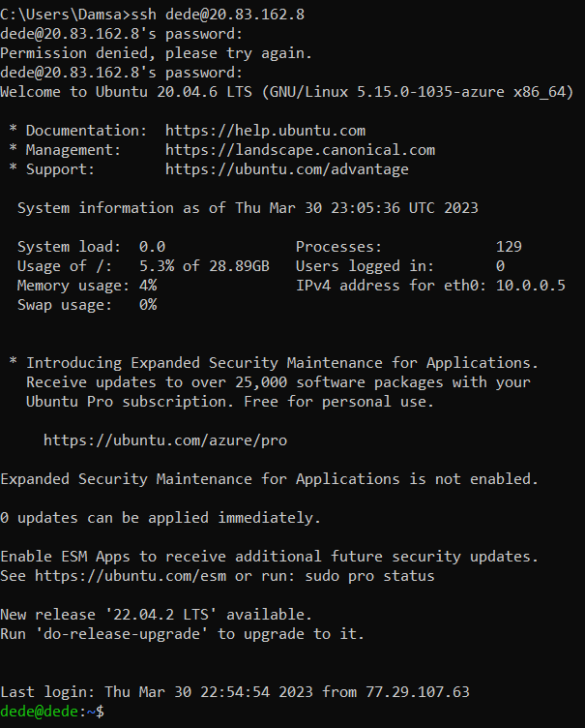

5. Install Apache Web Server.

For this step we will use the simple command ‘sudo apt install apache2’

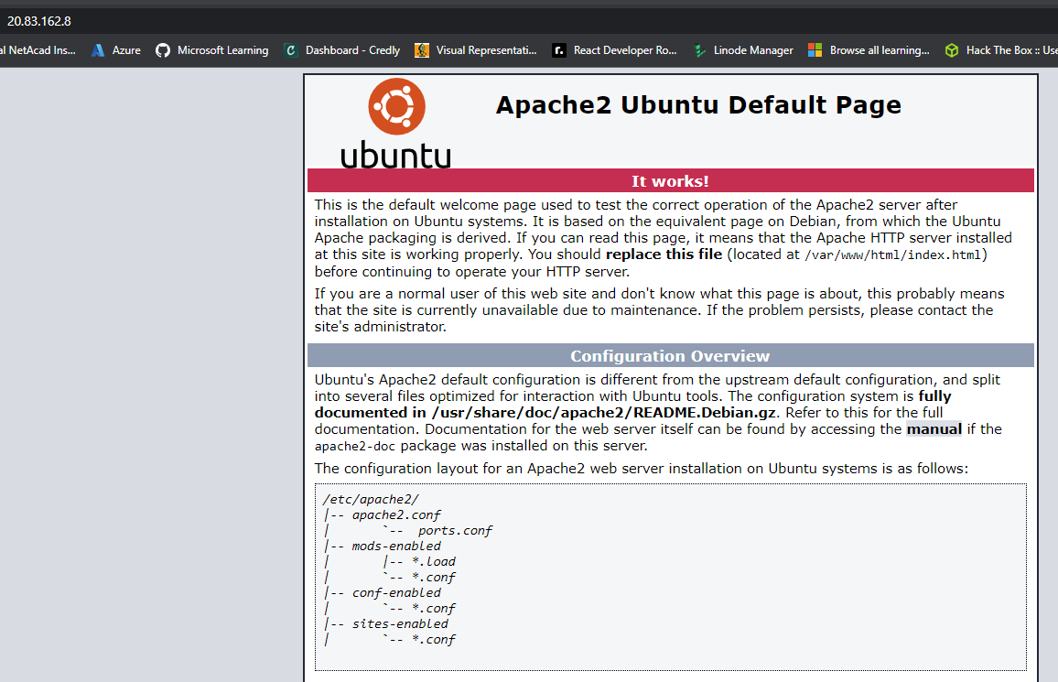

6. Deploy the “Hello World” web page.

In this step we need to modify the index.html file which is located in /var/www/html

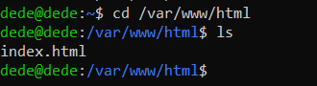

The index file we will replace with the code for the Hello world page.

We will use the command sudo nano index.html and replace the content with our code for Hello world page.

7. Provide Testing from your cellphone.

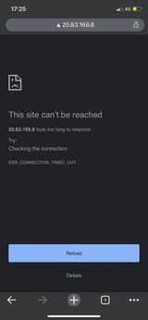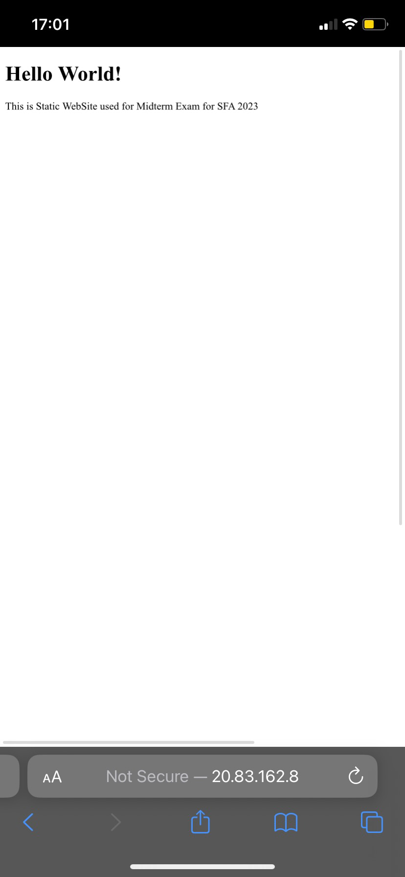

If we run a test from our phone on wifi connect it will access the page because the phone shares the same IP adress with the local computer

On the second picture we are trying to access the page from our phone with 4G it shows that we cant access the page since the phone has different IP adress when connected with 4g

8. Provide the steps and results.

